



**Submitted by**

**KUNCHALA CHANDRA SHEKAR**

**KUMBUM AKHIL REDDY**

**GOMARAPU REVANTH REDDY**

**KACHAM SANJANA**

**Documentation: Hosting a Static Website on Azure Storage Account**

Hosting a static website on Azure Storage is a straightforward, cost-effective solution for lightweight web applications like personal blogs, portfolios, or documentation. This guide walks you through the process of creating and deploying a static website using Azure's **Storage Account** service.

**1. Create a Storage Account**

A Storage Account serves as the foundation for hosting static websites.

* **Steps to create a Storage Account:**
  1. Open the **Azure Portal** and navigate to **Storage Accounts**.

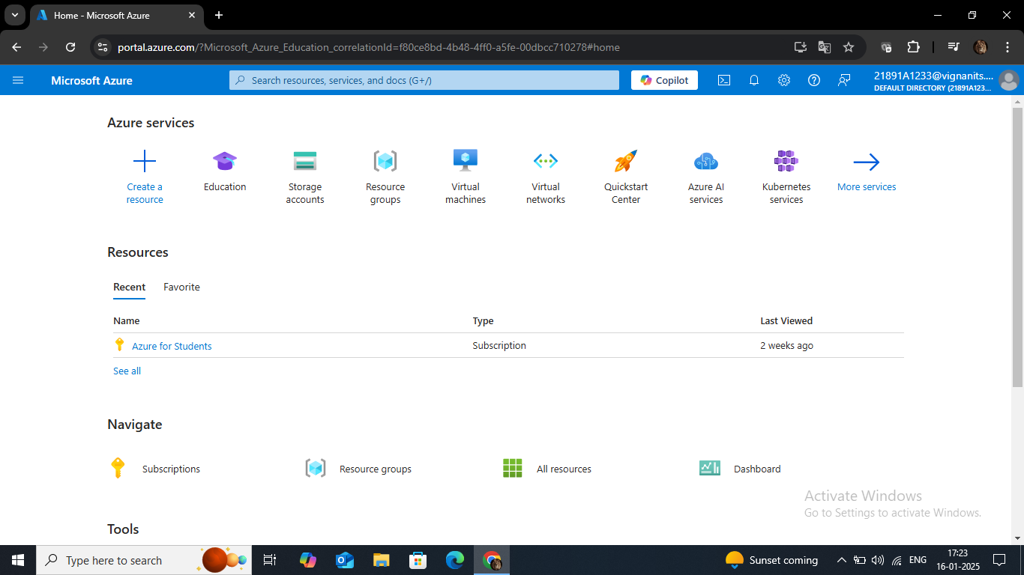

* 1. Click **Create** to start the creation process.

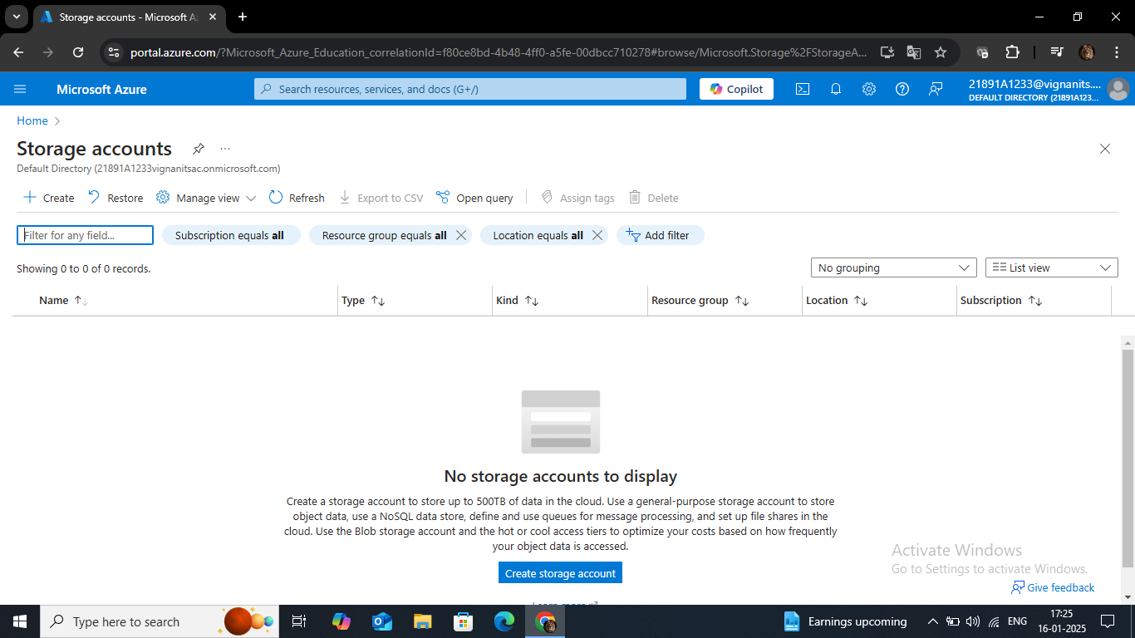

* 1. Fill in the required details:
     + **Subscription**: Select the subscription under which the resource will be billed.

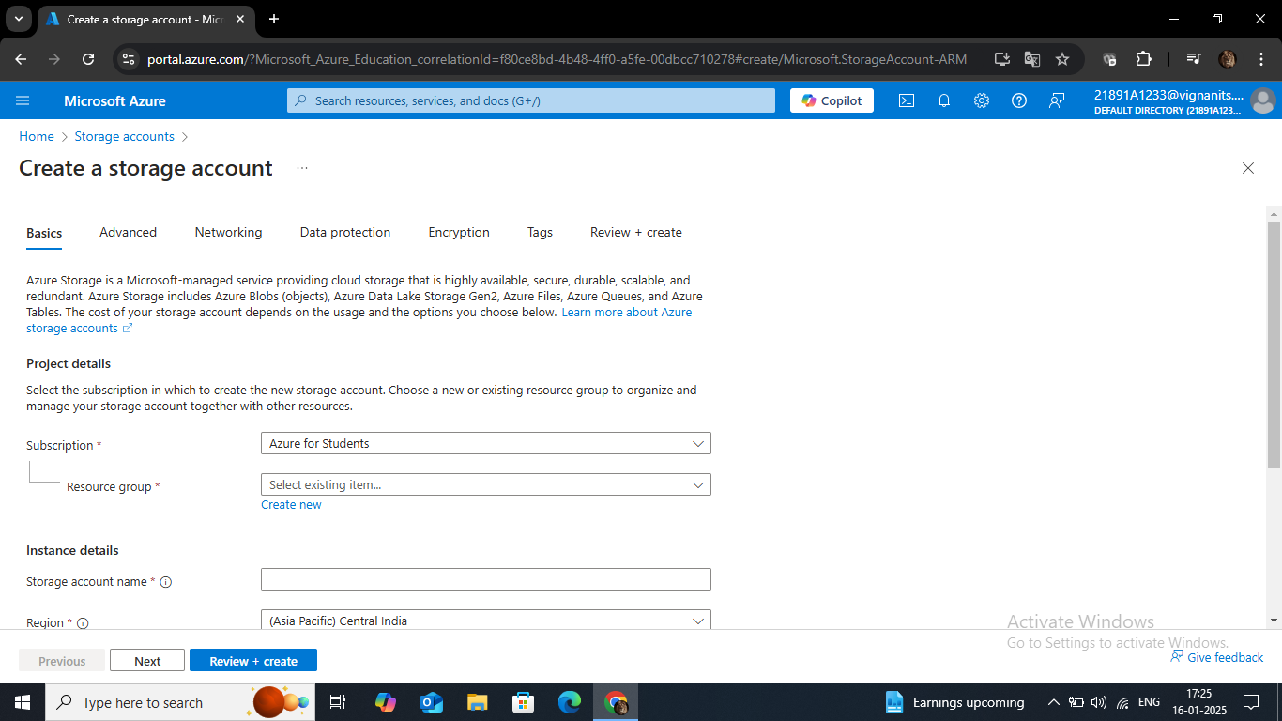

* + - **Resource Group**: Choose an existing resource group or create a new one for better organization.

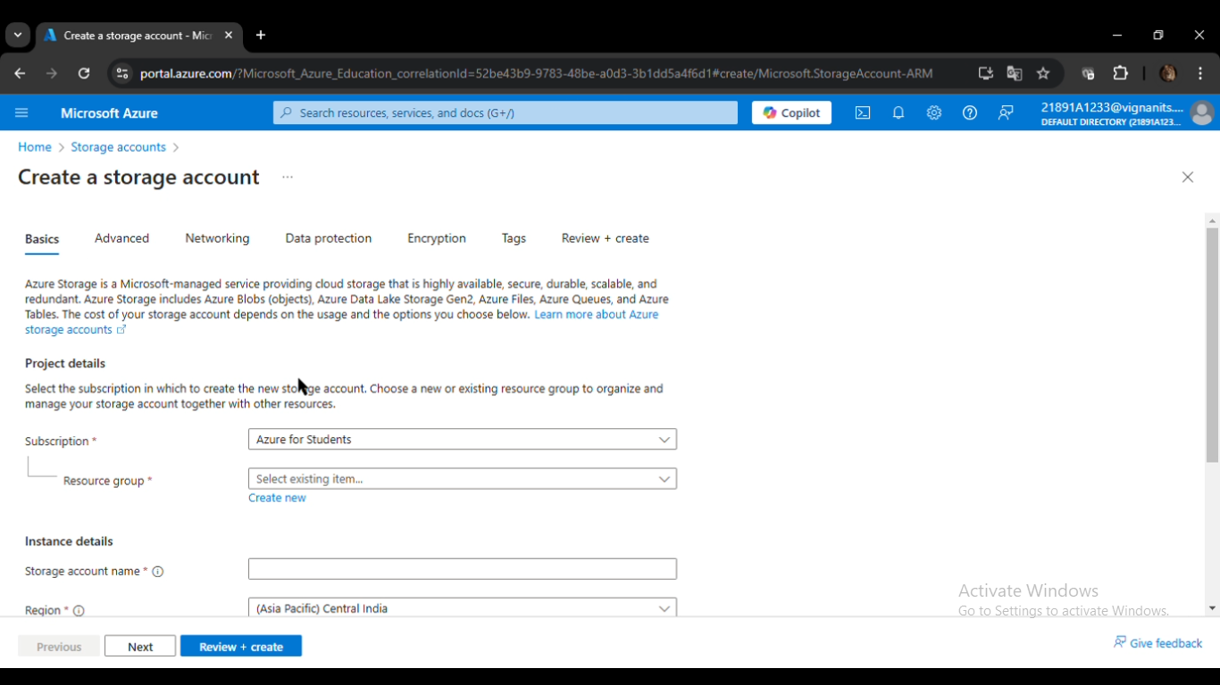

* + - **Storage Account Name**: Enter a unique name that meets Azure's naming requirements.

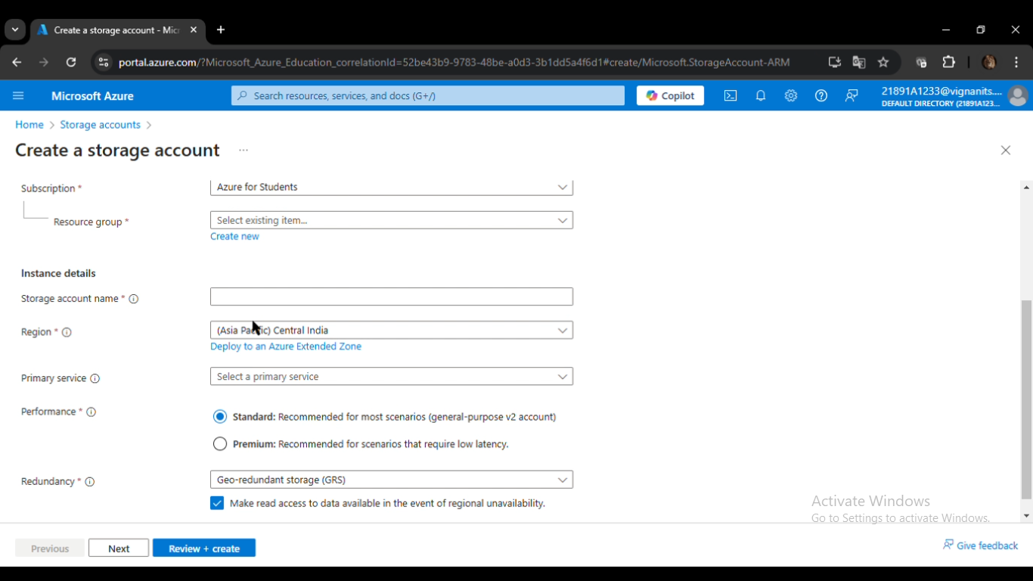

* + - **Region**: Select the nearest region to your target audience for reduced latency.
    - **Performance**: Opt for **Standard** performance, which is sufficient for hosting static websites.
    - **Redundancy**: Choose the appropriate redundancy option (e.g., **LRS** for local redundancy or **GRS** for geo-redundancy, ensuring data availability in case of regional failures).
  1. Review your selections, then click **Create** and wait for the deployment to complete.

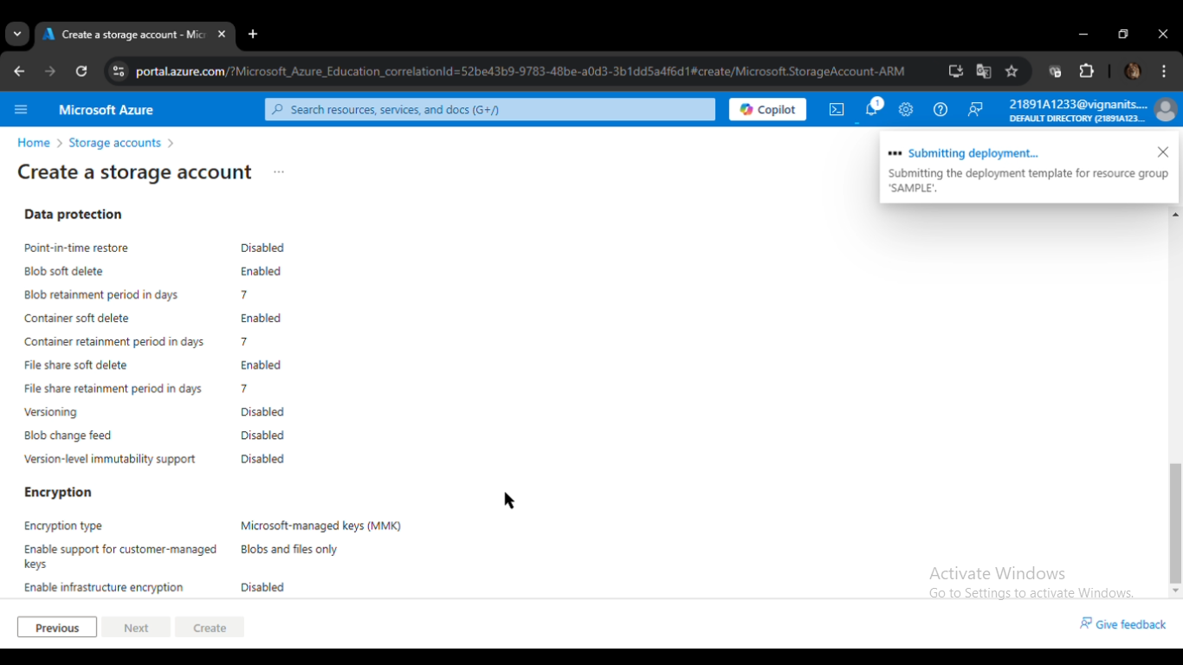

Once the Storage Account is created, it can be used to store and serve your static website.

**2. Create a Web Page**

To host a static website, you need at least one HTML file (commonly named index.html).

* **Steps to create a basic web page:**
  1. Use any text editor (e.g., Notepad, Visual Studio Code, or Sublime Text) to create an HTML file.
  2. Write simple HTML code with custom text or styling. For example:
  3. <!doctype html>
  4. <html class="no-js" lang="zxx">
  5. <head>
  6. <!-- Meta Tags -->
  7. <meta charset="utf-8">
  8. <meta http-equiv="X-UA-Compatible" content="IE=edge">
  9. <meta name="keywords" content="Site keywords here">
  10. <meta name="description" content="">
  11. <meta name='copyright' content=''>
  12. <meta name="viewport" content="width=device-width, initial-scale=1, shrink-to-fit=no">
  14. <!-- Title -->
  15. <title>Mediplus - Free Medical and Doctor Directory HTML Template.</title>
  17. <!-- Favicon -->
  18. <link rel="icon" href="img/favicon.png">
  20. <!-- Google Fonts -->
  21. <link href="https://fonts.googleapis.com/css?family=Poppins:200i,300,300i,400,400i,500,500i,600,600i,700,700i,800,800i,900,900i&display=swap" rel="stylesheet">
  22. <!-- Bootstrap CSS -->
  23. <link rel="stylesheet" href="css/bootstrap.min.css">
  24. <!-- Nice Select CSS -->
  25. <link rel="stylesheet" href="css/nice-select.css">
  26. <!-- Font Awesome CSS -->
  27. <link rel="stylesheet" href="css/font-awesome.min.css">
  28. <!-- icofont CSS -->
  29. <link rel="stylesheet" href="css/icofont.css">
  30. <!-- Slicknav -->
  31. <link rel="stylesheet" href="css/slicknav.min.css">
  32. <!-- Owl Carousel CSS -->
  33. <link rel="stylesheet" href="css/owl-carousel.css">
  34. <!-- Datepicker CSS -->
  35. <link rel="stylesheet" href="css/datepicker.css">
  36. <!-- Animate CSS -->
  37. <link rel="stylesheet" href="css/animate.min.css">
  38. <!-- Magnific Popup CSS -->
  39. <link rel="stylesheet" href="css/magnific-popup.css">
  41. <!-- Medipro CSS -->
  42. <link rel="stylesheet" href="css/normalize.css">
  43. <link rel="stylesheet" href="style.css">
  44. <link rel="stylesheet" href="css/responsive.css">
  46. </head>
  47. <body>
  49. <!-- Preloader -->
  50. <div class="preloader">
  51. <div class="loader">
  52. <div class="loader-outter"></div>
  53. <div class="loader-inner"></div>
  54. <div class="indicator">
  55. <svg width="16px" height="12px">
  56. <polyline id="back" points="1 6 4 6 6 11 10 1 12 6 15 6"></polyline>
  57. <polyline id="front" points="1 6 4 6 6 11 10 1 12 6 15 6"></polyline>
  58. </svg>
  59. </div>
  60. </div>
  61. </div>
  62. <!-- End Preloader -->
  64. <!-- Get Pro Button -->
  65. <ul class="pro-features">
  66. <a class="get-pro" href="#">Get Pro</a>
  67. <li class="big-title">Pro Version Available on Themeforest</li>
  68. <li class="title">Pro Version Features</li>
  69. <li>2+ premade home pages</li>
  70. <li>20+ html pages</li>
  71. <li>Color Plate With 12+ Colors</li>
  72. <li>Sticky Header / Sticky Filters</li>
  73. <li>Working Contact Form With Google Map</li>
  74. <div class="button">
  75. <a href="http://preview.themeforest.net/item/mediplus-medical-and-doctor-html-template/full_screen_preview/26665910?_ga=2.145092285.888558928.1591971968-344530658.1588061879" target="_blank" class="btn">Pro Version Demo</a>
  76. <a href="https://themeforest.net/item/mediplus-medical-and-doctor-html-template/26665910" target="_blank" class="btn">Buy Pro Version</a>
  77. </div>
  78. </ul>
  80. <!-- Header Area -->
  81. <header class="header" >
  82. <!-- Topbar -->
  83. <div class="topbar">
  84. <div class="container">
  85. <div class="row">
  86. <div class="col-lg-6 col-md-5 col-12">
  87. <!-- Contact -->
  88. <ul class="top-link">
  89. <li><a href="#">About</a></li>
  90. <li><a href="#">Doctors</a></li>
  91. <li><a href="#">Contact</a></li>
  92. <li><a href="#">FAQ</a></li>
  93. </ul>
  94. <!-- End Contact -->
  95. </div>
  96. <div class="col-lg-6 col-md-7 col-12">
  97. <!-- Top Contact -->
  98. <ul class="top-contact">
  99. <li><i class="fa fa-phone"></i>+91 9391218910</li>
  100. <li><i class="fa fa-envelope"></i><a href="mailto:support@yourmail.com">kunchalachandu41@gmail.com</a></li>
  101. </ul>
  102. <!-- End Top Contact -->
  103. </div>
  104. </div>
  105. </div>
  106. </div>
  107. <!-- End Topbar -->
  108. <!-- Header Inner -->
  109. <div class="header-inner">
  110. <div class="container">
  111. <div class="inner">
  112. <div class="row">
  113. <div class="col-lg-3 col-md-3 col-12">
  114. <!-- Start Logo -->
  115. <div class="logo">
  116. <a href="index.html"><img src="img/logo.png" alt="#"></a>
  117. </div>
  118. <!-- End Logo -->
  119. <!-- Mobile Nav -->
  120. <div class="mobile-nav"></div>
  121. <!-- End Mobile Nav -->
  122. </div>
  123. <div class="col-lg-7 col-md-9 col-12">
  124. <!-- Main Menu -->
  125. <div class="main-menu">
  126. <nav class="navigation">
  127. <ul class="nav menu">
  128. <li class="active"><a href="#">Home <i class="icofont-rounded-down"></i></a>
  129. <ul class="dropdown">
  130. <li><a href="index.html">Home Page 1</a></li>
  131. </ul>
  132. </li>
  133. <li><a href="#">Doctos </a></li>
  134. <li><a href="#">Services </a></li>
  135. <li><a href="#">Pages <i class="icofont-rounded-down"></i></a>
  136. <ul class="dropdown">
  137. <li><a href="404.html">404 Error</a></li>
  138. </ul>
  139. </li>
  140. <li><a href="#">Blogs <i class="icofont-rounded-down"></i></a>
  141. <ul class="dropdown">
  142. <li><a href="blog-single.html">Blog Details</a></li>
  143. </ul>
  144. </li>
  145. <li><a href="contact.html">Contact Us</a></li>
  146. </ul>
  147. </nav>
  148. </div>
  149. <!--/ End Main Menu -->
  150. </div>
  151. <div class="col-lg-2 col-12">
  152. <div class="get-quote">
  153. <a href="appointment.html" class="btn">Book Appointment</a>
  154. </div>
  155. </div>
  156. </div>
  157. </div>
  158. </div>
  159. </div>
  160. <!--/ End Header Inner -->
  161. </header>
  162. <!-- End Header Area -->
  164. <!-- Slider Area -->
  165. <section class="slider">
  166. <div class="hero-slider">
  167. <!-- Start Single Slider -->
  168. <div class="single-slider" style="background-image:url('img/slider2.jpg')">
  169. <div class="container">
  170. <div class="row">
  171. <div class="col-lg-7">
  172. <div class="text">
  173. <h1>We Provide <span>Medical</span> Services That You Can <span>Trust!</span></h1>
  174. <p>Lorem ipsum dolor sit amet, consectetur adipiscing elit. Mauris sed nisl pellentesque, faucibus libero eu, gravida quam. </p>
  175. <div class="button">
  176. <a href="#" class="btn">Get Appointment</a>
  177. <a href="#" class="btn primary">Learn More</a>
  178. </div>
  179. </div>
  180. </div>
  181. </div>
  182. </div>
  183. </div>
  184. <!-- End Single Slider -->
  185. <!-- Start Single Slider -->
  186. <div class="single-slider" style="background-image:url('img/slider.jpg')">
  187. <div class="container">
  188. <div class="row">
  189. <div class="col-lg-7">
  190. <div class="text">
  191. <h1>We Provide <span>Medical</span> Services That You Can <span>Trust!</span></h1>
  192. <p>Lorem ipsum dolor sit amet, consectetur adipiscing elit. Mauris sed nisl pellentesque, faucibus libero eu, gravida quam. </p>
  193. <div class="button">
  194. <a href="#" class="btn">Get Appointment</a>
  195. <a href="#" class="btn primary">About Us</a>
  196. </div>
  197. </div>
  198. </div>
  199. </div>
  200. </div>
  201. </div>
  202. <!-- Start End Slider -->
  203. <!-- Start Single Slider -->
  204. <div class="single-slider" style="background-image:url('img/slider3.jpg')">
  205. <div class="container">
  206. <div class="row">
  207. <div class="col-lg-7">
  208. <div class="text">
  209. <h1>We Provide <span>Medical</span> Services That You Can <span>Trust!</span></h1>
  210. <p>Lorem ipsum dolor sit amet, consectetur adipiscing elit. Mauris sed nisl pellentesque, faucibus libero eu, gravida quam. </p>
  211. <div class="button">
  212. <a href="#" class="btn">Get Appointment</a>
  213. <a href="#" class="btn primary">Conatct Now</a>
  214. </div>
  215. </div>
  216. </div>
  217. </div>
  218. </div>
  219. </div>
  220. <!-- End Single Slider -->
  221. </div>
  222. </section>
  223. <!--/ End Slider Area -->
  225. <!-- Start Schedule Area -->
  226. <section class="schedule">
  227. <div class="container">
  228. <div class="schedule-inner">
  229. <div class="row">
  230. <div class="col-lg-4 col-md-6 col-12 ">
  231. <!-- single-schedule -->
  232. <div class="single-schedule first">
  233. <div class="inner">
  234. <div class="icon">
  235. <i class="fa fa-ambulance"></i>
  236. </div>
  237. <div class="single-content">
  238. <span>Lorem Amet</span>
  239. <h4>Emergency Cases</h4>
  240. <p>Lorem ipsum sit amet consectetur adipiscing elit. Vivamus et erat in lacus convallis sodales.</p>
  241. <a href="#">LEARN MORE<i class="fa fa-long-arrow-right"></i></a>
  242. </div>
  243. </div>
  244. </div>
  245. </div>
  246. <div class="col-lg-4 col-md-6 col-12">
  247. <!-- single-schedule -->
  248. <div class="single-schedule middle">
  249. <div class="inner">
  250. <div class="icon">
  251. <i class="icofont-prescription"></i>
  252. </div>
  253. <div class="single-content">
  254. <span>Fusce Porttitor</span>
  255. <h4>Doctors Timetable</h4>
  256. <p>Lorem ipsum sit amet consectetur adipiscing elit. Vivamus et erat in lacus convallis sodales.</p>
  257. <a href="#">LEARN MORE<i class="fa fa-long-arrow-right"></i></a>
  258. </div>
  259. </div>
  260. </div>
  261. </div>
  262. <div class="col-lg-4 col-md-12 col-12">
  263. <!-- single-schedule -->
  264. <div class="single-schedule last">
  265. <div class="inner">
  266. <div class="icon">
  267. <i class="icofont-ui-clock"></i>
  268. </div>
  269. <div class="single-content">
  270. <span>Donec luctus</span>
  271. <h4>Opening Hours</h4>
  272. <ul class="time-sidual">
  273. <li class="day">Monday - Fridayp <span>8.00-20.00</span></li>
  274. <li class="day">Saturday <span>9.00-18.30</span></li>
  275. <li class="day">Monday - Thusday <span>9.00-15.00</span></li>
  276. </ul>
  277. <a href="#">LEARN MORE<i class="fa fa-long-arrow-right"></i></a>
  278. </div>
  279. </div>
  280. </div>
  281. </div>
  282. </div>
  283. </div>
  284. </div>
  285. </section>
  286. <!--/End Start schedule Area -->
  287. <!-- Start Feautes -->
  288. <section class="Feautes section">
  289. <div class="container">
  290. <div class="row">
  291. <div class="col-lg-12">
  292. <div class="section-title">
  293. <h2>We Are Always Ready to Help You & Your Family</h2>
  294. <img src="img/section-img.png" alt="#">
  295. <p>Lorem ipsum dolor sit amet consectetur adipiscing elit praesent aliquet. pretiumts</p>
  296. </div>
  297. </div>
  298. </div>
  299. <div class="row">
  300. <div class="col-lg-4 col-12">
  301. <!-- Start Single features -->
  302. <div class="single-features">
  303. <div class="signle-icon">
  304. <i class="icofont icofont-ambulance-cross"></i>
  305. </div>
  306. <h3>Emergency Help</h3>
  307. <p>Lorem ipsum sit, consectetur adipiscing elit. Maecenas mi quam vulputate.</p>
  308. </div>
  309. <!-- End Single features -->
  310. </div>
  311. <div class="col-lg-4 col-12">
  312. <!-- Start Single features -->
  313. <div class="single-features">
  314. <div class="signle-icon">
  315. <i class="icofont icofont-medical-sign-alt"></i>
  316. </div>
  317. <h3>Enriched Pharmecy</h3>
  318. <p>Lorem ipsum sit, consectetur adipiscing elit. Maecenas mi quam vulputate.</p>
  319. </div>
  320. <!-- End Single features -->
  321. </div>
  322. <div class="col-lg-4 col-12">
  323. <!-- Start Single features -->
  324. <div class="single-features last">
  325. <div class="signle-icon">
  326. <i class="icofont icofont-stethoscope"></i>
  327. </div>
  328. <h3>Medical Treatment</h3>
  329. <p>Lorem ipsum sit, consectetur adipiscing elit. Maecenas mi quam vulputate.</p>
  330. </div>
  331. <!-- End Single features -->
  332. </div>
  333. </div>
  334. </div>
  335. </section>
  336. <!--/ End Feautes -->
  338. <!-- Start Fun-facts -->
  339. <div id="fun-facts" class="fun-facts section overlay">
  340. <div class="container">
  341. <div class="row">
  342. <div class="col-lg-3 col-md-6 col-12">
  343. <!-- Start Single Fun -->
  344. <div class="single-fun">
  345. <i class="icofont icofont-home"></i>
  346. <div class="content">
  347. <span class="counter">3468</span>
  348. <p>Hospital Rooms</p>
  349. </div>
  350. </div>
  351. <!-- End Single Fun -->
  352. </div>
  353. <div class="col-lg-3 col-md-6 col-12">
  354. <!-- Start Single Fun -->
  355. <div class="single-fun">
  356. <i class="icofont icofont-user-alt-3"></i>
  357. <div class="content">
  358. <span class="counter">557</span>
  359. <p>Specialist Doctors</p>
  360. </div>
  361. </div>
  362. <!-- End Single Fun -->
  363. </div>
  364. <div class="col-lg-3 col-md-6 col-12">
  365. <!-- Start Single Fun -->
  366. <div class="single-fun">
  367. <i class="icofont-simple-smile"></i>
  368. <div class="content">
  369. <span class="counter">4379</span>
  370. <p>Happy Patients</p>
  371. </div>
  372. </div>
  373. <!-- End Single Fun -->
  374. </div>
  375. <div class="col-lg-3 col-md-6 col-12">
  376. <!-- Start Single Fun -->
  377. <div class="single-fun">
  378. <i class="icofont icofont-table"></i>
  379. <div class="content">
  380. <span class="counter">32</span>
  381. <p>Years of Experience</p>
  382. </div>
  383. </div>
  384. <!-- End Single Fun -->
  385. </div>
  386. </div>
  387. </div>
  388. </div>
  389. <!--/ End Fun-facts -->
  391. <!-- Start Why choose -->
  392. <section class="why-choose section" >
  393. <div class="container">
  394. <div class="row">
  395. <div class="col-lg-12">
  396. <div class="section-title">
  397. <h2>We Offer Different Services To Improve Your Health</h2>
  398. <img src="img/section-img.png" alt="#">
  399. <p>Lorem ipsum dolor sit amet consectetur adipiscing elit praesent aliquet. pretiumts</p>
  400. </div>
  401. </div>
  402. </div>
  403. <div class="row">
  404. <div class="col-lg-6 col-12">
  405. <!-- Start Choose Left -->
  406. <div class="choose-left">
  407. <h3>Who We Are</h3>
  408. <p>Lorem ipsum dolor sit amet, consectetur adipiscing elit. Maecenas pharetra antege vel est lobortis, a commodo magna rhoncus. In quis nisi non emet quam pharetra commodo. </p>
  409. <p>Class aptent taciti sociosqu ad litora torquent per conubia nostra, per inceptos himenaeos. </p>
  410. <div class="row">
  411. <div class="col-lg-6">
  412. <ul class="list">
  413. <li><i class="fa fa-caret-right"></i>Maecenas vitae luctus nibh. </li>
  414. <li><i class="fa fa-caret-right"></i>Duis massa massa.</li>
  415. <li><i class="fa fa-caret-right"></i>Aliquam feugiat interdum.</li>
  416. </ul>
  417. </div>
  418. <div class="col-lg-6">
  419. <ul class="list">
  420. <li><i class="fa fa-caret-right"></i>Maecenas vitae luctus nibh. </li>
  421. <li><i class="fa fa-caret-right"></i>Duis massa massa.</li>
  422. <li><i class="fa fa-caret-right"></i>Aliquam feugiat interdum.</li>
  423. </ul>
  424. </div>
  425. </div>
  426. </div>
  427. <!-- End Choose Left -->
  428. </div>
  429. <div class="col-lg-6 col-12">
  430. <!-- Start Choose Rights -->
  431. <div class="choose-right">
  432. <div class="video-image">
  433. <!-- Video Animation -->
  434. <div class="promo-video">
  435. <div class="waves-block">
  436. <div class="waves wave-1"></div>
  437. <div class="waves wave-2"></div>
  438. <div class="waves wave-3"></div>
  439. </div>
  440. </div>
  441. <!--/ End Video Animation -->
  442. <a href="https://www.youtube.com/watch?v=RFVXy6CRVR4" class="video video-popup mfp-iframe"><i class="fa fa-play"></i></a>
  443. </div>
  444. </div>
  445. <!-- End Choose Rights -->
  446. </div>
  447. </div>
  448. </div>
  449. </section>
  450. <!--/ End Why choose -->
  452. <!-- Start Call to action -->
  453. <section class="call-action overlay" data-stellar-background-ratio="0.5">
  454. <div class="container">
  455. <div class="row">
  456. <div class="col-lg-12 col-md-12 col-12">
  457. <div class="content">
  458. <h2>Do you need Emergency Medical Care? Call @ 1234 56789</h2>
  459. <p>Lorem ipsum dolor sit amet, consectetur adipiscing elit. Quisque porttitor dictum turpis nec gravida.</p>
  460. <div class="button">
  461. <a href="#" class="btn">Contact Now</a>
  462. <a href="#" class="btn second">Learn More<i class="fa fa-long-arrow-right"></i></a>
  463. </div>
  464. </div>
  465. </div>
  466. </div>
  467. </div>
  468. </section>
  469. <!--/ End Call to action -->
  471. <!-- Start portfolio -->
  472. <section class="portfolio section" >
  473. <div class="container">
  474. <div class="row">
  475. <div class="col-lg-12">
  476. <div class="section-title">
  477. <h2>We Maintain Cleanliness Rules Inside Our Hospital</h2>
  478. <img src="img/section-img.png" alt="#">
  479. <p>Lorem ipsum dolor sit amet consectetur adipiscing elit praesent aliquet. pretiumts</p>
  480. </div>
  481. </div>
  482. </div>
  483. </div>
  484. <div class="container-fluid">
  485. <div class="row">
  486. <div class="col-lg-12 col-12">
  487. <div class="owl-carousel portfolio-slider">
  488. <div class="single-pf">
  489. <img src="img/pf1.jpg" alt="#">
  490. <a href="portfolio-details.html" class="btn">View Details</a>
  491. </div>
  492. <div class="single-pf">
  493. <img src="img/pf2.jpg" alt="#">
  494. <a href="portfolio-details.html" class="btn">View Details</a>
  495. </div>
  496. <div class="single-pf">
  497. <img src="img/pf3.jpg" alt="#">
  498. <a href="portfolio-details.html" class="btn">View Details</a>
  499. </div>
  500. <div class="single-pf">
  501. <img src="img/pf4.jpg" alt="#">
  502. <a href="portfolio-details.html" class="btn">View Details</a>
  503. </div>
  504. <div class="single-pf">
  505. <img src="img/pf1.jpg" alt="#">
  506. <a href="portfolio-details.html" class="btn">View Details</a>
  507. </div>
  508. <div class="single-pf">
  509. <img src="img/pf2.jpg" alt="#">
  510. <a href="portfolio-details.html" class="btn">View Details</a>
  511. </div>
  512. <div class="single-pf">
  513. <img src="img/pf3.jpg" alt="#">
  514. <a href="portfolio-details.html" class="btn">View Details</a>
  515. </div>
  516. <div class="single-pf">
  517. <img src="img/pf4.jpg" alt="#">
  518. <a href="portfolio-details.html" class="btn">View Details</a>
  519. </div>
  520. </div>
  521. </div>
  522. </div>
  523. </div>
  524. </section>
  525. <!--/ End portfolio -->
  527. <!-- Start service -->
  528. <section class="services section">
  529. <div class="container">
  530. <div class="row">
  531. <div class="col-lg-12">
  532. <div class="section-title">
  533. <h2>We Offer Different Services To Improve Your Health</h2>
  534. <img src="img/section-img.png" alt="#">
  535. <p>Lorem ipsum dolor sit amet consectetur adipiscing elit praesent aliquet. pretiumts</p>
  536. </div>
  537. </div>
  538. </div>
  539. <div class="row">
  540. <div class="col-lg-4 col-md-6 col-12">
  541. <!-- Start Single Service -->
  542. <div class="single-service">
  543. <i class="icofont icofont-prescription"></i>
  544. <h4><a href="service-details.html">General Treatment</a></h4>
  545. <p>Lorem ipsum dolor sit amet, consectetur adipiscing elit. Donec luctus dictum eros ut imperdiet. </p>
  546. </div>
  547. <!-- End Single Service -->
  548. </div>
  549. <div class="col-lg-4 col-md-6 col-12">
  550. <!-- Start Single Service -->
  551. <div class="single-service">
  552. <i class="icofont icofont-tooth"></i>
  553. <h4><a href="service-details.html">Teeth Whitening</a></h4>
  554. <p>Lorem ipsum dolor sit amet, consectetur adipiscing elit. Donec luctus dictum eros ut imperdiet. </p>
  555. </div>
  556. <!-- End Single Service -->
  557. </div>
  558. <div class="col-lg-4 col-md-6 col-12">
  559. <!-- Start Single Service -->
  560. <div class="single-service">
  561. <i class="icofont icofont-heart-alt"></i>
  562. <h4><a href="service-details.html">Heart Surgery</a></h4>
  563. <p>Lorem ipsum dolor sit amet, consectetur adipiscing elit. Donec luctus dictum eros ut imperdiet. </p>
  564. </div>
  565. <!-- End Single Service -->
  566. </div>
  567. <div class="col-lg-4 col-md-6 col-12">
  568. <!-- Start Single Service -->
  569. <div class="single-service">
  570. <i class="icofont icofont-listening"></i>
  571. <h4><a href="service-details.html">Ear Treatment</a></h4>
  572. <p>Lorem ipsum dolor sit amet, consectetur adipiscing elit. Donec luctus dictum eros ut imperdiet. </p>
  573. </div>
  574. <!-- End Single Service -->
  575. </div>
  576. <div class="col-lg-4 col-md-6 col-12">
  577. <!-- Start Single Service -->
  578. <div class="single-service">
  579. <i class="icofont icofont-eye-alt"></i>
  580. <h4><a href="service-details.html">Vision Problems</a></h4>
  581. <p>Lorem ipsum dolor sit amet, consectetur adipiscing elit. Donec luctus dictum eros ut imperdiet. </p>
  582. </div>
  583. <!-- End Single Service -->
  584. </div>
  585. <div class="col-lg-4 col-md-6 col-12">
  586. <!-- Start Single Service -->
  587. <div class="single-service">
  588. <i class="icofont icofont-blood"></i>
  589. <h4><a href="service-details.html">Blood Transfusion</a></h4>
  590. <p>Lorem ipsum dolor sit amet, consectetur adipiscing elit. Donec luctus dictum eros ut imperdiet. </p>
  591. </div>
  592. <!-- End Single Service -->
  593. </div>
  594. </div>
  595. </div>
  596. </section>
  597. <!--/ End service -->
  599. <!-- Pricing Table -->
  600. <section class="pricing-table section">
  601. <div class="container">
  602. <div class="row">
  603. <div class="col-lg-12">
  604. <div class="section-title">
  605. <h2>We Provide You The Best Treatment In Resonable Price</h2>
  606. <img src="img/section-img.png" alt="#">
  607. <p>Lorem ipsum dolor sit amet consectetur adipiscing elit praesent aliquet. pretiumts</p>
  608. </div>
  609. </div>
  610. </div>
  611. <div class="row">
  612. <!-- Single Table -->
  613. <div class="col-lg-4 col-md-12 col-12">
  614. <div class="single-table">
  615. <!-- Table Head -->
  616. <div class="table-head">
  617. <div class="icon">
  618. <i class="icofont icofont-ui-cut"></i>
  619. </div>
  620. <h4 class="title">Plastic Suggery</h4>
  621. <div class="price">
  622. <p class="amount">$199<span>/ Per Visit</span></p>
  623. </div>
  624. </div>
  625. <!-- Table List -->
  626. <ul class="table-list">
  627. <li><i class="icofont icofont-ui-check"></i>Lorem ipsum dolor sit</li>
  628. <li><i class="icofont icofont-ui-check"></i>Cubitur sollicitudin fentum</li>
  629. <li class="cross"><i class="icofont icofont-ui-close"></i>Nullam interdum enim</li>
  630. <li class="cross"><i class="icofont icofont-ui-close"></i>Donec ultricies metus</li>
  631. <li class="cross"><i class="icofont icofont-ui-close"></i>Pellentesque eget nibh</li>
  632. </ul>
  633. <div class="table-bottom">
  634. <a class="btn" href="#">Book Now</a>
  635. </div>
  636. <!-- Table Bottom -->
  637. </div>
  638. </div>
  639. <!-- End Single Table-->
  640. <!-- Single Table -->
  641. <div class="col-lg-4 col-md-12 col-12">
  642. <div class="single-table">
  643. <!-- Table Head -->
  644. <div class="table-head">
  645. <div class="icon">
  646. <i class="icofont icofont-tooth"></i>
  647. </div>
  648. <h4 class="title">Teeth Whitening</h4>
  649. <div class="price">
  650. <p class="amount">$299<span>/ Per Visit</span></p>
  651. </div>
  652. </div>
  653. <!-- Table List -->
  654. <ul class="table-list">
  655. <li><i class="icofont icofont-ui-check"></i>Lorem ipsum dolor sit</li>
  656. <li><i class="icofont icofont-ui-check"></i>Cubitur sollicitudin fentum</li>
  657. <li><i class="icofont icofont-ui-check"></i>Nullam interdum enim</li>
  658. <li class="cross"><i class="icofont icofont-ui-close"></i>Donec ultricies metus</li>
  659. <li class="cross"><i class="icofont icofont-ui-close"></i>Pellentesque eget nibh</li>
  660. </ul>
  661. <div class="table-bottom">
  662. <a class="btn" href="#">Book Now</a>
  663. </div>
  664. <!-- Table Bottom -->
  665. </div>
  666. </div>
  667. <!-- End Single Table-->
  668. <!-- Single Table -->
  669. <div class="col-lg-4 col-md-12 col-12">
  670. <div class="single-table">
  671. <!-- Table Head -->
  672. <div class="table-head">
  673. <div class="icon">
  674. <i class="icofont-heart-beat"></i>
  675. </div>
  676. <h4 class="title">Heart Suggery</h4>
  677. <div class="price">
  678. <p class="amount">$399<span>/ Per Visit</span></p>
  679. </div>
  680. </div>
  681. <!-- Table List -->
  682. <ul class="table-list">
  683. <li><i class="icofont icofont-ui-check"></i>Lorem ipsum dolor sit</li>
  684. <li><i class="icofont icofont-ui-check"></i>Cubitur sollicitudin fentum</li>
  685. <li><i class="icofont icofont-ui-check"></i>Nullam interdum enim</li>
  686. <li><i class="icofont icofont-ui-check"></i>Donec ultricies metus</li>
  687. <li><i class="icofont icofont-ui-check"></i>Pellentesque eget nibh</li>
  688. </ul>
  689. <div class="table-bottom">
  690. <a class="btn" href="#">Book Now</a>
  691. </div>
  692. <!-- Table Bottom -->
  693. </div>
  694. </div>
  695. <!-- End Single Table-->
  696. </div>
  697. </div>
  698. </section>
  699. <!--/ End Pricing Table -->


  703. <!-- Start Blog Area -->
  704. <section class="blog section" id="blog">
  705. <div class="container">
  706. <div class="row">
  707. <div class="col-lg-12">
  708. <div class="section-title">
  709. <h2>Keep up with Our Most Recent Medical News.</h2>
  710. <img src="img/section-img.png" alt="#">
  711. <p>Lorem ipsum dolor sit amet consectetur adipiscing elit praesent aliquet. pretiumts</p>
  712. </div>
  713. </div>
  714. </div>
  715. <div class="row">
  716. <div class="col-lg-4 col-md-6 col-12">
  717. <!-- Single Blog -->
  718. <div class="single-news">
  719. <div class="news-head">
  720. <img src="img/blog1.jpg" alt="#">
  721. </div>
  722. <div class="news-body">
  723. <div class="news-content">
  724. <div class="date">22 Aug, 2020</div>
  725. <h2><a href="blog-single.html">We have annnocuced our new product.</a></h2>
  726. <p class="text">Lorem ipsum dolor a sit ameti, consectetur adipisicing elit, sed do eiusmod tempor incididunt sed do incididunt sed.</p>
  727. </div>
  728. </div>
  729. </div>
  730. <!-- End Single Blog -->
  731. </div>
  732. <div class="col-lg-4 col-md-6 col-12">
  733. <!-- Single Blog -->
  734. <div class="single-news">
  735. <div class="news-head">
  736. <img src="img/blog2.jpg" alt="#">
  737. </div>
  738. <div class="news-body">
  739. <div class="news-content">
  740. <div class="date">15 Jul, 2020</div>
  741. <h2><a href="blog-single.html">Top five way for solving teeth problems.</a></h2>
  742. <p class="text">Lorem ipsum dolor a sit ameti, consectetur adipisicing elit, sed do eiusmod tempor incididunt sed do incididunt sed.</p>
  743. </div>
  744. </div>
  745. </div>
  746. <!-- End Single Blog -->
  747. </div>
  748. <div class="col-lg-4 col-md-6 col-12">
  749. <!-- Single Blog -->
  750. <div class="single-news">
  751. <div class="news-head">
  752. <img src="img/blog3.jpg" alt="#">
  753. </div>
  754. <div class="news-body">
  755. <div class="news-content">
  756. <div class="date">05 Jan, 2020</div>
  757. <h2><a href="blog-single.html">We provide highly business soliutions.</a></h2>
  758. <p class="text">Lorem ipsum dolor a sit ameti, consectetur adipisicing elit, sed do eiusmod tempor incididunt sed do incididunt sed.</p>
  759. </div>
  760. </div>
  761. </div>
  762. <!-- End Single Blog -->
  763. </div>
  764. </div>
  765. </div>
  766. </section>
  767. <!-- End Blog Area -->
  769. <!-- Start clients -->
  770. <div class="clients overlay">
  771. <div class="container">
  772. <div class="row">
  773. <div class="col-lg-12 col-md-12 col-12">
  774. <div class="owl-carousel clients-slider">
  775. <div class="single-clients">
  776. <img src="img/client1.png" alt="#">
  777. </div>
  778. <div class="single-clients">
  779. <img src="img/client2.png" alt="#">
  780. </div>
  781. <div class="single-clients">
  782. <img src="img/client3.png" alt="#">
  783. </div>
  784. <div class="single-clients">
  785. <img src="img/client4.png" alt="#">
  786. </div>
  787. <div class="single-clients">
  788. <img src="img/client5.png" alt="#">
  789. </div>
  790. <div class="single-clients">
  791. <img src="img/client1.png" alt="#">
  792. </div>
  793. <div class="single-clients">
  794. <img src="img/client2.png" alt="#">
  795. </div>
  796. <div class="single-clients">
  797. <img src="img/client3.png" alt="#">
  798. </div>
  799. <div class="single-clients">
  800. <img src="img/client4.png" alt="#">
  801. </div>
  802. </div>
  803. </div>
  804. </div>
  805. </div>
  806. </div>
  807. <!--/Ens clients -->
  809. <!-- Start Appointment -->
  810. <section class="appointment">
  811. <div class="container">
  812. <div class="row">
  813. <div class="col-lg-12">
  814. <div class="section-title">
  815. <h2>We Are Always Ready to Help You. Book An Appointment</h2>
  816. <img src="img/section-img.png" alt="#">
  817. <p>Lorem ipsum dolor sit amet consectetur adipiscing elit praesent aliquet. pretiumts</p>
  818. </div>
  819. </div>
  820. </div>
  821. <div class="row">
  822. <div class="col-lg-6 col-md-12 col-12">
  823. <form class="form" action="#">
  824. <div class="row">
  825. <div class="col-lg-6 col-md-6 col-12">
  826. <div class="form-group">
  827. <input name="name" type="text" placeholder="Name">
  828. </div>
  829. </div>
  830. <div class="col-lg-6 col-md-6 col-12">
  831. <div class="form-group">
  832. <input name="email" type="email" placeholder="Email">
  833. </div>
  834. </div>
  835. <div class="col-lg-6 col-md-6 col-12">
  836. <div class="form-group">
  837. <input name="phone" type="text" placeholder="Phone">
  838. </div>
  839. </div>
  840. <div class="col-lg-6 col-md-6 col-12">
  841. <div class="form-group">
  842. <div class="nice-select form-control wide" tabindex="0"><span class="current">Department</span>
  843. <ul class="list">
  844. <li data-value="1" class="option selected ">Department</li>
  845. <li data-value="2" class="option">Cardiac Clinic</li>
  846. <li data-value="3" class="option">Neurology</li>
  847. <li data-value="4" class="option">Dentistry</li>
  848. <li data-value="5" class="option">Gastroenterology</li>
  849. </ul>
  850. </div>
  851. </div>
  852. </div>
  853. <div class="col-lg-6 col-md-6 col-12">
  854. <div class="form-group">
  855. <div class="nice-select form-control wide" tabindex="0"><span class="current">Doctor</span>
  856. <ul class="list">
  857. <li data-value="1" class="option selected ">Doctor</li>
  858. <li data-value="2" class="option">Dr. Akther Hossain</li>
  859. <li data-value="3" class="option">Dr. Dery Alex</li>
  860. <li data-value="4" class="option">Dr. Jovis Karon</li>
  861. </ul>
  862. </div>
  863. </div>
  864. </div>
  865. <div class="col-lg-6 col-md-6 col-12">
  866. <div class="form-group">
  867. <input type="text" placeholder="Date" id="datepicker">
  868. </div>
  869. </div>
  870. <div class="col-lg-12 col-md-12 col-12">
  871. <div class="form-group">
  872. <textarea name="message" placeholder="Write Your Message Here....."></textarea>
  873. </div>
  874. </div>
  875. </div>
  876. <div class="row">
  877. <div class="col-lg-5 col-md-4 col-12">
  878. <div class="form-group">
  879. <div class="button">
  880. <button type="submit" class="btn">Book An Appointment</button>
  881. </div>
  882. </div>
  883. </div>
  884. <div class="col-lg-7 col-md-8 col-12">
  885. <p>( We will be confirm by an Text Message )</p>
  886. </div>
  887. </div>
  888. </form>
  889. </div>
  890. <div class="col-lg-6 col-md-12 ">
  891. <div class="appointment-image">
  892. <img src="img/contact-img.png" alt="#">
  893. </div>
  894. </div>
  895. </div>
  896. </div>
  897. </section>
  898. <!-- End Appointment -->
  900. <!-- Start Newsletter Area -->
  901. <section class="newsletter section">
  902. <div class="container">
  903. <div class="row ">
  904. <div class="col-lg-6 col-12">
  905. <!-- Start Newsletter Form -->
  906. <div class="subscribe-text ">
  907. <h6>Sign up for newsletter</h6>
  908. <p class="">Cu qui soleat partiendo urbanitas. Eum aperiri indoctum eu,<br> homero alterum.</p>
  909. </div>
  910. <!-- End Newsletter Form -->
  911. </div>
  912. <div class="col-lg-6 col-12">
  913. <!-- Start Newsletter Form -->
  914. <div class="subscribe-form ">
  915. <form action="mail/mail.php" method="get" target="_blank" class="newsletter-inner">
  916. <input name="EMAIL" placeholder="Your email address" class="common-input" onfocus="this.placeholder = ''"
  917. onblur="this.placeholder = 'Your email address'" required="" type="email">
  918. <button class="btn">Subscribe</button>
  919. </form>
  920. </div>
  921. <!-- End Newsletter Form -->
  922. </div>
  923. </div>
  924. </div>
  925. </section>
  926. <!-- /End Newsletter Area -->
  928. <!-- Footer Area -->
  929. <footer id="footer" class="footer ">
  930. <!-- Footer Top -->
  931. <div class="footer-top">
  932. <div class="container">
  933. <div class="row">
  934. <div class="col-lg-3 col-md-6 col-12">
  935. <div class="single-footer">
  936. <h2>About Us</h2>
  937. <p>Lorem ipsum dolor sit am consectetur adipisicing elit do eiusmod tempor incididunt ut labore dolore magna.</p>
  938. <!-- Social -->
  939. <ul class="social">
  940. <li><a href="#"><i class="icofont-facebook"></i></a></li>
  941. <li><a href="#"><i class="icofont-google-plus"></i></a></li>
  942. <li><a href="#"><i class="icofont-twitter"></i></a></li>
  943. <li><a href="#"><i class="icofont-vimeo"></i></a></li>
  944. <li><a href="#"><i class="icofont-pinterest"></i></a></li>
  945. </ul>
  946. <!-- End Social -->
  947. </div>
  948. </div>
  949. <div class="col-lg-3 col-md-6 col-12">
  950. <div class="single-footer f-link">
  951. <h2>Quick Links</h2>
  952. <div class="row">
  953. <div class="col-lg-6 col-md-6 col-12">
  954. <ul>
  955. <li><a href="#"><i class="fa fa-caret-right" aria-hidden="true"></i>Home</a></li>
  956. <li><a href="#"><i class="fa fa-caret-right" aria-hidden="true"></i>About Us</a></li>
  957. <li><a href="#"><i class="fa fa-caret-right" aria-hidden="true"></i>Services</a></li>
  958. <li><a href="#"><i class="fa fa-caret-right" aria-hidden="true"></i>Our Cases</a></li>
  959. <li><a href="#"><i class="fa fa-caret-right" aria-hidden="true"></i>Other Links</a></li>
  960. </ul>
  961. </div>
  962. <div class="col-lg-6 col-md-6 col-12">
  963. <ul>
  964. <li><a href="#"><i class="fa fa-caret-right" aria-hidden="true"></i>Consuling</a></li>
  965. <li><a href="#"><i class="fa fa-caret-right" aria-hidden="true"></i>Finance</a></li>
  966. <li><a href="#"><i class="fa fa-caret-right" aria-hidden="true"></i>Testimonials</a></li>
  967. <li><a href="#"><i class="fa fa-caret-right" aria-hidden="true"></i>FAQ</a></li>
  968. <li><a href="#"><i class="fa fa-caret-right" aria-hidden="true"></i>Contact Us</a></li>
  969. </ul>
  970. </div>
  971. </div>
  972. </div>
  973. </div>
  974. <div class="col-lg-3 col-md-6 col-12">
  975. <div class="single-footer">
  976. <h2>Open Hours</h2>
  977. <p>Lorem ipsum dolor sit ame consectetur adipisicing elit do eiusmod tempor incididunt.</p>
  978. <ul class="time-sidual">
  979. <li class="day">Monday - Fridayp <span>8.00-20.00</span></li>
  980. <li class="day">Saturday <span>9.00-18.30</span></li>
  981. <li class="day">Monday - Thusday <span>9.00-15.00</span></li>
  982. </ul>
  983. </div>
  984. </div>
  985. <div class="col-lg-3 col-md-6 col-12">
  986. <div class="single-footer">
  987. <h2>Newsletter</h2>
  988. <p>subscribe to our newsletter to get allour news in your inbox.. Lorem ipsum dolor sit amet, consectetur adipisicing elit,</p>
  989. <form action="mail/mail.php" method="get" target="_blank" class="newsletter-inner">
  990. <input name="email" placeholder="Email Address" class="common-input" onfocus="this.placeholder = ''"
  991. onblur="this.placeholder = 'Your email address'" required="" type="email">
  992. <button class="button"><i class="icofont icofont-paper-plane"></i></button>
  993. </form>
  994. </div>
  995. </div>
  996. </div>
  997. </div>
  998. </div>
  999. <!--/ End Footer Top -->
  1000. <!-- Copyright -->
  1001. <div class="copyright">
  1002. <div class="container">
  1003. <div class="row">
  1004. <div class="col-lg-12 col-md-12 col-12">
  1005. <div class="copyright-content">
  1006. <p>© Copyright 2018 | All Rights Reserved by <a href="https://www.wpthemesgrid.com" target="_blank">wpthemesgrid.com</a> </p>
  1007. </div>
  1008. </div>
  1009. </div>
  1010. </div>
  1011. </div>
  1012. <!--/ End Copyright -->
  1013. </footer>
  1014. <!--/ End Footer Area -->
  1016. <!-- jquery Min JS -->
  1017. <script src="js/jquery.min.js"></script>
  1018. <!-- jquery Migrate JS -->
  1019. <script src="js/jquery-migrate-3.0.0.js"></script>
  1020. <!-- jquery Ui JS -->
  1021. <script src="js/jquery-ui.min.js"></script>
  1022. <!-- Easing JS -->
  1023. <script src="js/easing.js"></script>
  1024. <!-- Color JS -->
  1025. <script src="js/colors.js"></script>
  1026. <!-- Popper JS -->
  1027. <script src="js/popper.min.js"></script>
  1028. <!-- Bootstrap Datepicker JS -->
  1029. <script src="js/bootstrap-datepicker.js"></script>
  1030. <!-- Jquery Nav JS -->
  1031. <script src="js/jquery.nav.js"></script>
  1032. <!-- Slicknav JS -->
  1033. <script src="js/slicknav.min.js"></script>
  1034. <!-- ScrollUp JS -->
  1035. <script src="js/jquery.scrollUp.min.js"></script>
  1036. <!-- Niceselect JS -->
  1037. <script src="js/niceselect.js"></script>
  1038. <!-- Tilt Jquery JS -->
  1039. <script src="js/tilt.jquery.min.js"></script>
  1040. <!-- Owl Carousel JS -->
  1041. <script src="js/owl-carousel.js"></script>
  1042. <!-- counterup JS -->
  1043. <script src="js/jquery.counterup.min.js"></script>
  1044. <!-- Steller JS -->
  1045. <script src="js/steller.js"></script>
  1046. <!-- Wow JS -->
  1047. <script src="js/wow.min.js"></script>
  1048. <!-- Magnific Popup JS -->
  1049. <script src="js/jquery.magnific-popup.min.js"></script>
  1050. <!-- Counter Up CDN JS -->
  1051. <script src="http://cdnjs.cloudflare.com/ajax/libs/waypoints/2.0.3/waypoints.min.js"></script>
  1052. <!-- Bootstrap JS -->
  1053. <script src="js/bootstrap.min.js"></script>
  1054. <!-- Main JS -->
  1055. <script src="js/main.js"></script>
  1056. </body>
  1057. </html>Save the file as index.html on your local machine.

Feel free to add additional files like CSS, images, or JavaScript if your site requires them.

**3. Enable the Static Website Feature**

Azure Storage Accounts offer a dedicated **Static Website** feature to serve web content directly.

* **Steps to enable the Static Website feature:**
  1. Open the created Storage Account in the Azure Portal.
  2. Scroll down to the **Data Management** section in the left-hand panel and select **Static Website**.

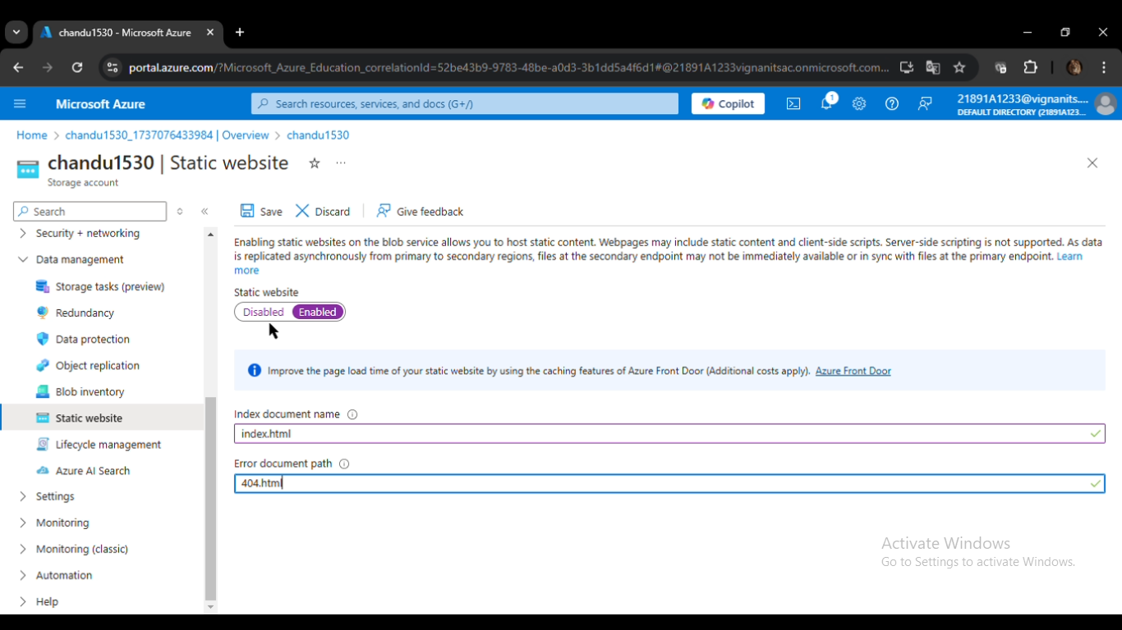

* 1. Click **Enable** to turn on the static website hosting.

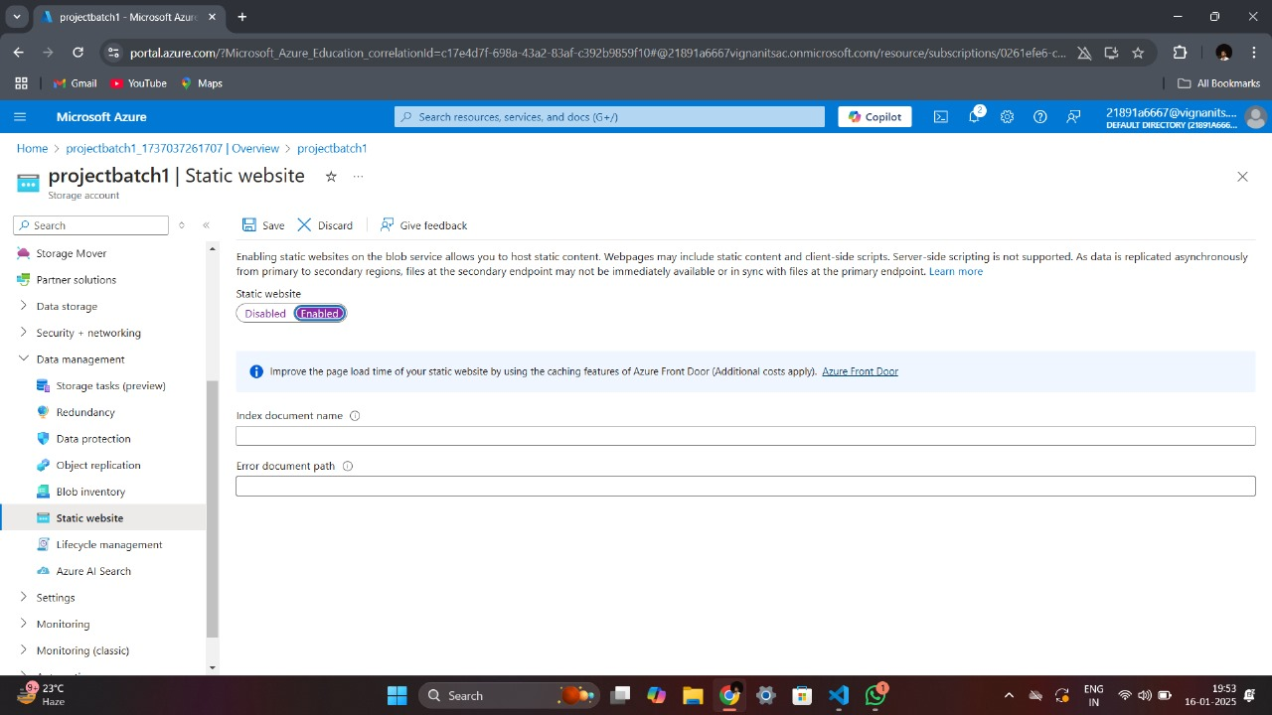

* 1. In the **Index document name** field, type index.html (or the main file name of your website).
     + This file will be displayed when users visit the root of your website.

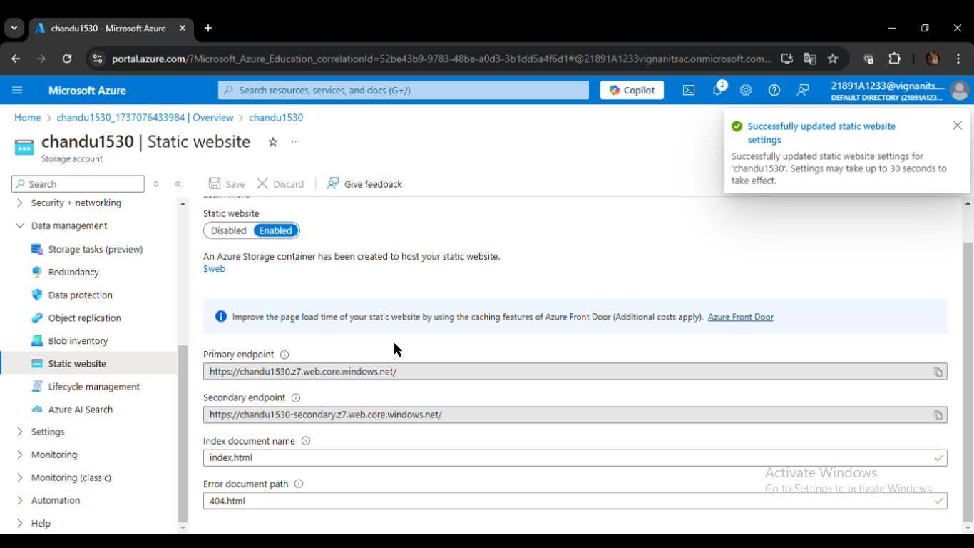

* 1. Save the settings.

Enabling this feature creates a special container called $web, which is reserved for storing website files.

**4. Access the $web Container**

The $web container acts as the directory where your website files are stored.

* **Steps to locate and open the $web container:**
  1. In the Storage Account, go to the **Containers** section under the **Data Storage** menu.

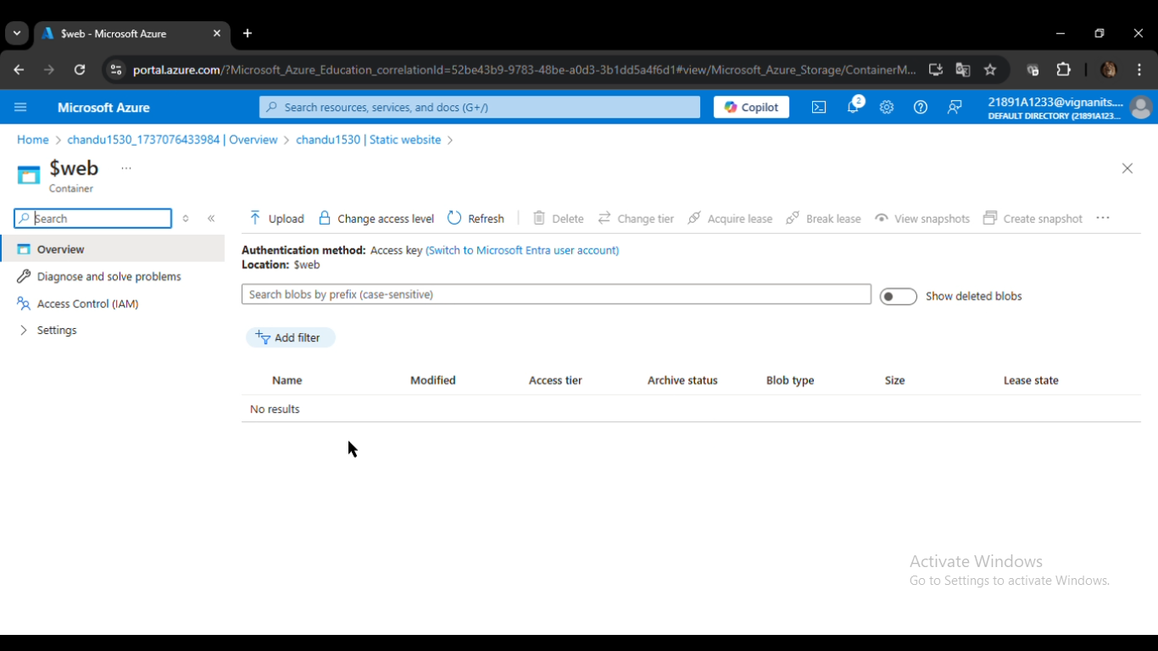

* 1. You will see a container named $web. Click on it to open.

**5. Upload Website Files**

Once the $web container is open, upload your website files.

* **Steps to upload files:**
  1. Click on the **Upload** button within the $web container.

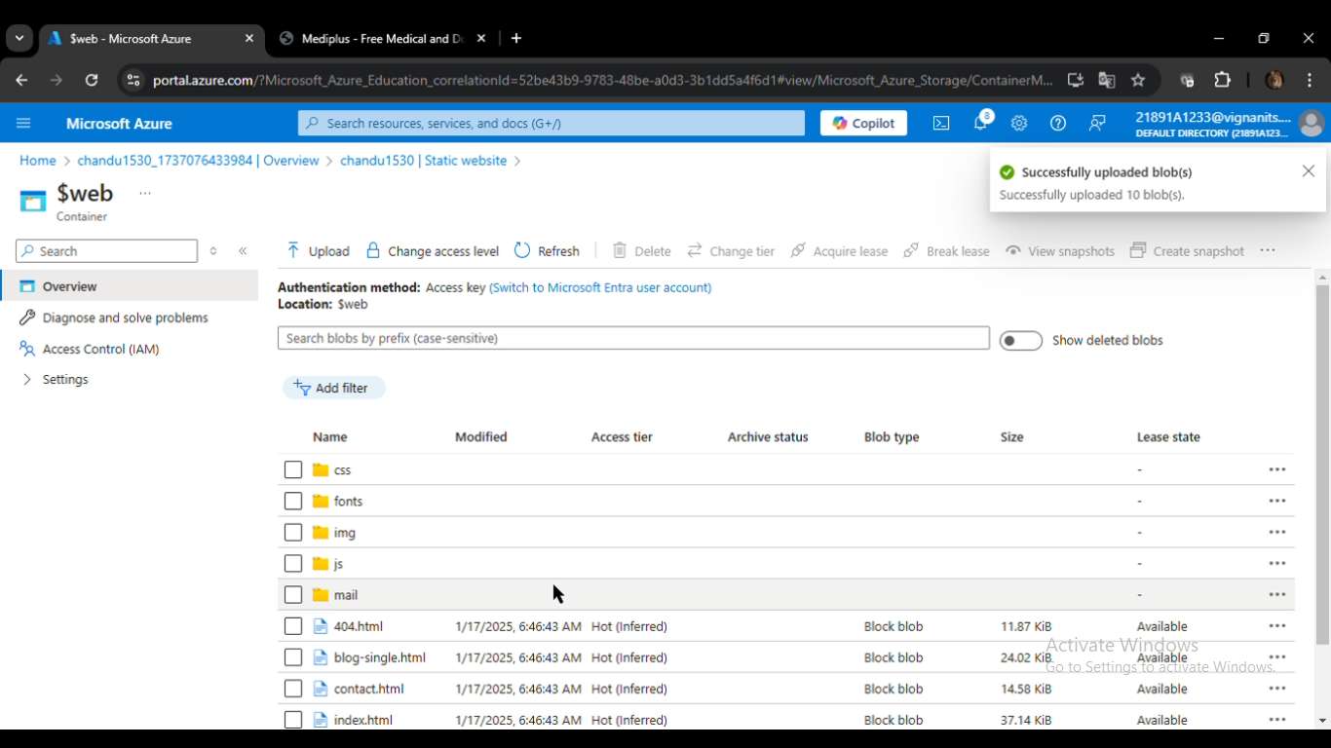

* 1. Use one of the following methods to upload files:
     + **Drag and Drop**: Drag your index.html (and other files, if any) into the upload area.
     + **Browse**: Click the **Browse** button to locate and select files manually.
  2. Click **Upload** to confirm and complete the process.

Your website files are now hosted in the $web container and ready to be served.

**6. Test the Static Website**

After uploading the files, Azure generates a **Primary Endpoint** URL to access the hosted site.

* **Steps to test your website:**
  1. Go back to the **Static Website** section of your Storage Account.
  2. Copy the **Primary Endpoint** URL displayed there.
  3. Paste the URL into a browser to access your website.
     + If the website displays correctly, your deployment was successful.
     + If you encounter errors, verify that the file names match the settings (e.g., index.html) and that all dependencies are uploaded.

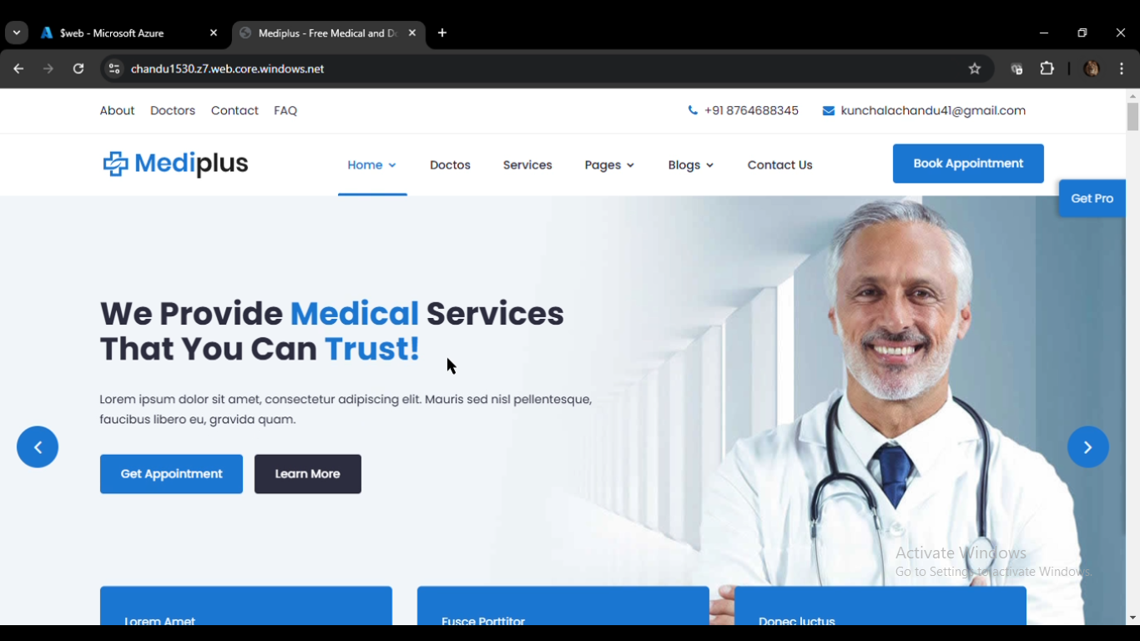

**Key Azure Services Used**

1. **Azure Storage Account**: The core service for storing and serving static website files.
2. **Static Website Feature**: Enables a container ($web) to host web files and generates a public URL for access.
3. **$web Container**: A dedicated container where all static website files are uploaded.
4. **Azure Portal**: The user-friendly interface for managing and configuring Azure resources.

**Benefits of Using Azure Storage for Static Websites**

1. **Cost-Effectiveness**: Hosting static websites on Azure Storage is significantly cheaper compared to using traditional web hosting solutions.
2. **High Availability**: Azure ensures data redundancy and availability, making your website resilient to failures.
3. **Scalability**: The service can handle traffic spikes without additional configuration.
4. **Simplicity**: No need to manage web servers or complex configurations.
5. **Global Reach**: Azure's globally distributed data centers ensure low-latency access for users worldwide.

**Conclusion**

By following the steps above, you can successfully host a static website on Azure Storage Account. This solution is ideal for lightweight, static content with minimal setup and maintenance.